1.Explain the need for databases in web applications.

🡪 Web applications are crucial in today's market due to their accessibility, scalability, and cost-effectiveness. They offer global reach, engaging user experiences, and valuable data insights. Businesses leverage web applications to gain a competitive advantage, adapt to changing market needs, and enhance customer engagement. With their ability to reach a wide audience, web applications play a vital role in driving growth and success in the digital landscape. And there is a need for databases in web applications for following:

1. Data Storage: Databases serve as a centralized repository for storing structured data, such as user information, product details, and transaction records.

2. Data Retrieval: They enable efficient retrieval of specific data based on various criteria, allowing web applications to dynamically generate content tailored to user requests.

3. Data Integrity: Databases enforce rules and constraints to maintain data consistency and accuracy, reducing the risk of errors and ensuring reliable information.

4. Concurrency Control: They manage simultaneous access to data by multiple users or processes, preventing conflicts and ensuring that changes are properly synchronized.

5. Scalability: Databases can scale vertically (by adding more resources to a single server) or horizontally (by distributing data across multiple servers), accommodating growing amounts of data and user traffic.

6. Security: Databases offer features like access control, encryption, and authentication mechanisms to protect sensitive data from unauthorized access, ensuring compliance with privacy regulations.

7. Data Analysis: They support complex queries and analytics, enabling businesses to gain insights from large datasets, identify trends, and make informed decisions to improve their products or services.

8. Data Persistence: Databases provide persistent storage, ensuring that data remains available and intact even in the event of application crashes or server failures, enhancing reliability and data durability.

2. Explain the use of global variables within functions.

🡪 Global variables are data values that can be accessed and modified from any part of a program, including within functions. They are defined outside of any specific function and can be utilized across different functions and modules within the program. While global variables offer convenience by providing a shared space for data, they can also lead to potential issues such as unintended modifications and difficulties in understanding the flow of the program. Therefore, it's essential to use global variables thoughtfully and limit their usage to cases where they are truly necessary for the functionality of the program.

Example:

<h1>Global Variable</h1>

<?php

$global = "global";

function *local*(){

    $global = "local";

    echo "The global is change to $global <br/>";

}

function *local1*(){

    $global = "local1";

    echo "The global is change to $global";

}

echo *local*();

echo *local1*();

?>

3. Demonstrate how to create a new database and user in MySQL using phpMyAdmin.

🡪 Below are the steps to create a new database and user in mySQL using phpMyAdmin:

To Create a Database:

Step 1:

Open the localhost/phpMyAdmin

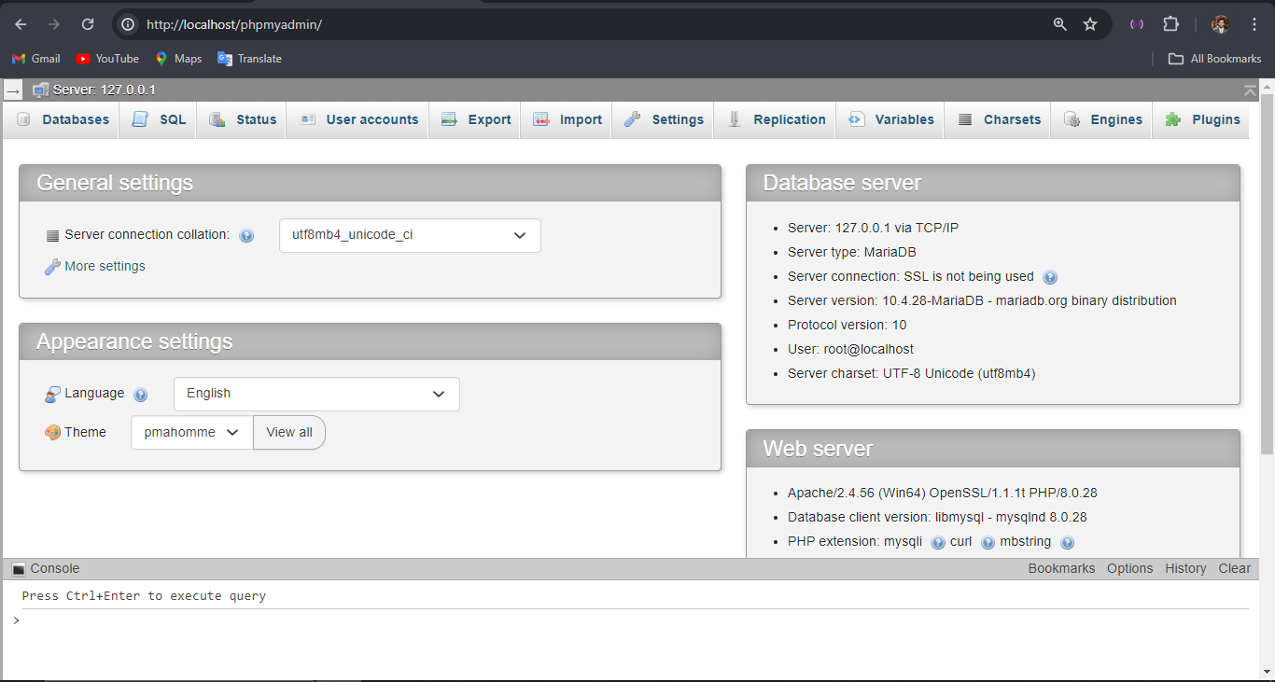

STEP 2:

Click the database and enter your database name

Example: My database name is “Hello_DB”

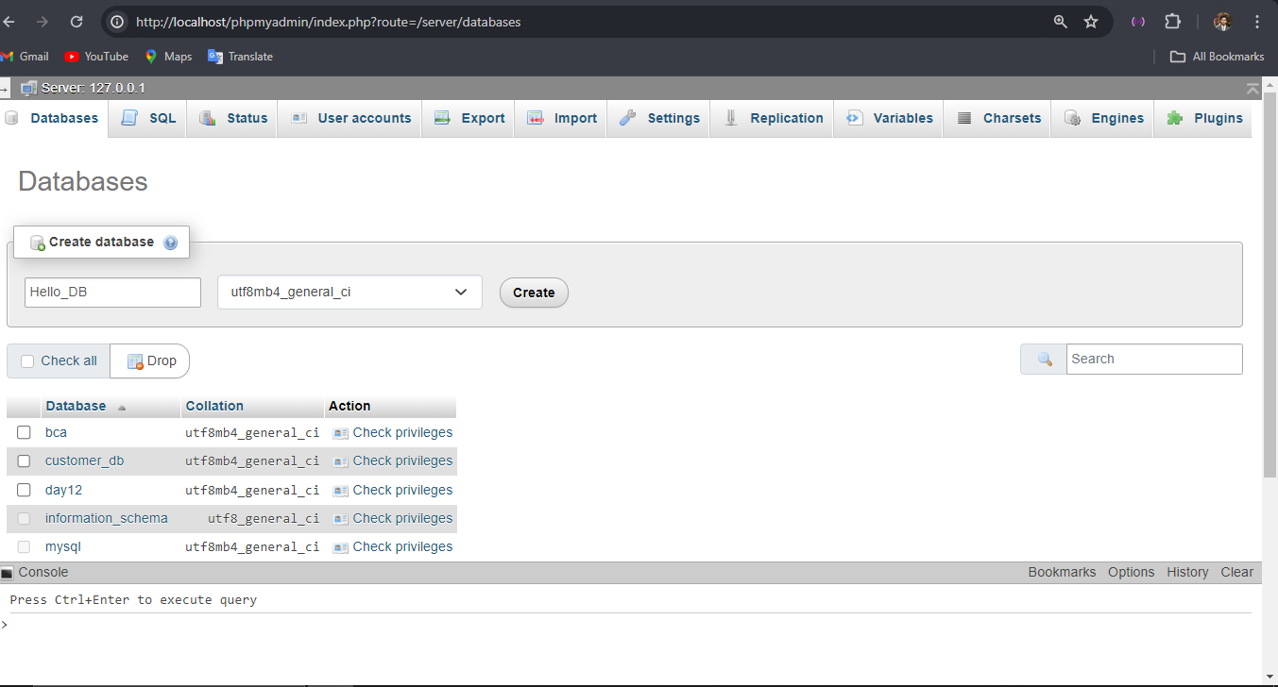

Step 3:

Click on Create and the database is created. 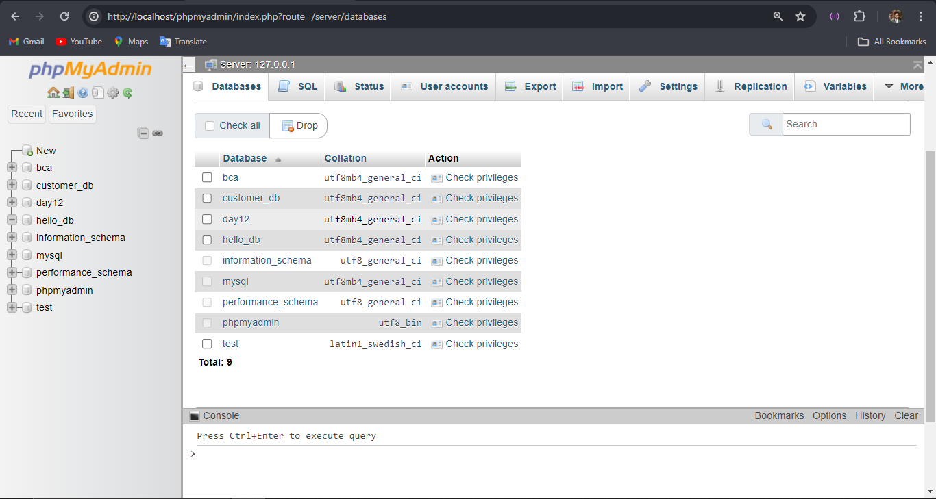

To create a user in the phpMyAdmin following steps are to be followed:

Step 1 : Navigate to the User accounts and click 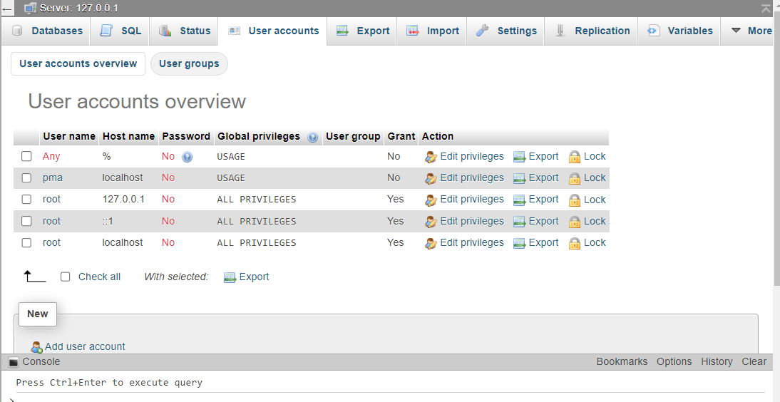

Step 2 : Click on Add user Account located at the bottom area

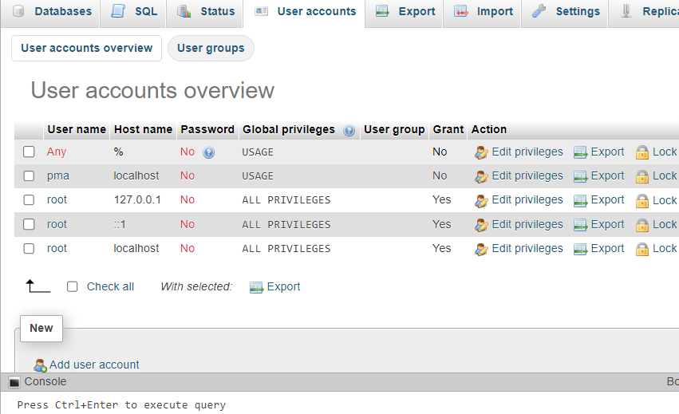

Step 3 : Fill all the required data and configure the settings according to your requirements.

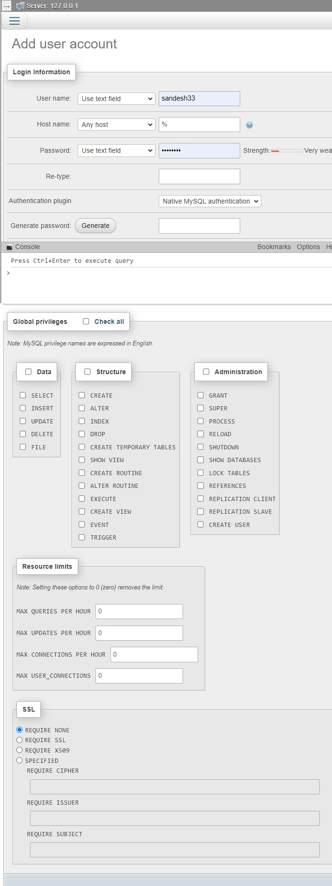

Click on the go and the user accounts will be created